Synopsis
Spam Email Detection System

Problem Id: 22

Student Name : Kartikeya Bali (Team Lead)
University Roll number: 2028740
Section:U
Student Name : Sumedha Thakur
University Roll number: 2028870
Section:U

- Problem Description:
Unsolicited and malicious emails, commonly known as spam, pose significant challenges to individuals and organizations by causing security risks, data breaches, phishing attacks, and reduced productivity. Manually identifying spam emails is inefficient and impractical due to the large volume of emails exchanged daily. Therefore, there is a need for an automated system that can accurately classify emails as spam or legitimate (ham).The objective of this project is to design and develop a Spam Email Detection System using Machine Learning techniques. The system will preprocess email text by removing stopwords, punctuation, and irrelevant characters, and convert textual data into numerical features using techniques such as TF-IDF or Bag-of-Words. Feature selection methods will be applied to retain high-impact keywords associated with spam. Classification algorithms such as Logistic Regression and Support Vector Machine (SVM) with different kernels (Linear, Polynomial, and RBF) will be implemented to train predictive models. The performance of these models will be evaluated using metrics like accuracy, confusion matrix, precision, recall, and F1-score to ensure reliable and efficient spam detection.
- Steps of Implementation:
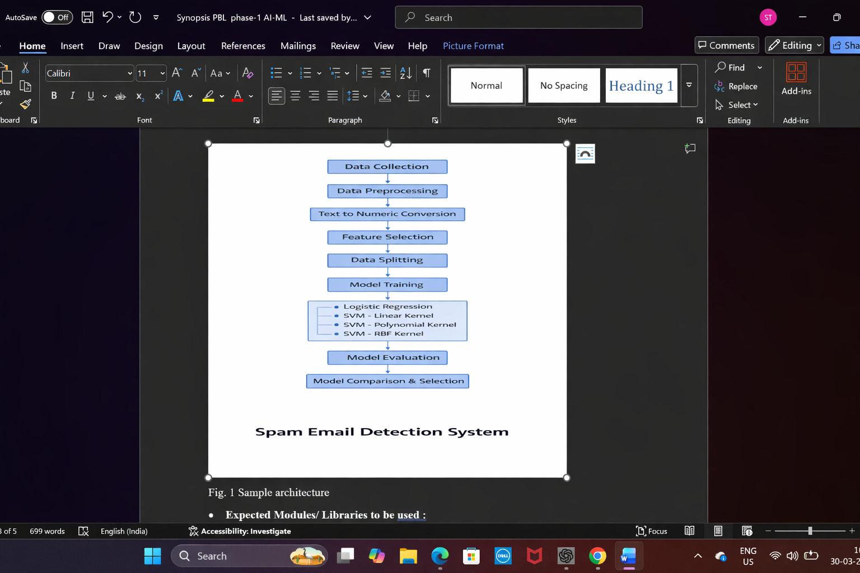

- Expected Modules/ Libraries to be used :
Inbuilt Modules
- re (Regular Expressions)
Used for text cleaning such as removing punctuation, special characters, and numbers.
- string
Provides string constants and functions to handle text processing.
- warnings
Used to ignore unnecessary warning messages during model training.

External (Custom/Third-Party) Libraries
- NumPy
Used for numerical operations and handling arrays efficiently.
- Pandas
Used for loading, manipulating, and analyzing the email dataset.
- NLTK (Natural Language Toolkit)
Used for text preprocessing tasks like tokenization, stopword removal, and stemming.
- Scikit-learn (sklearn)
Provides machine learning algorithms and tools for:
  - TF-IDF / CountVectorizer
  - Logistic Regression
  - Support Vector Machine (SVM)
  - Train-test split
  - Evaluation metrics
- Matplotlib
Used to visualize results such as confusion matrix or accuracy comparison graphs.
- Seaborn
Used for better visualization of confusion matrix and performance plots.

- Expected Evaluation metrics and Plots to be used:
To evaluate the performance of the Spam Email Detection System, the following metrics and visualization plots will be used:
Evaluation Metrics
- Accuracy
Measures the overall percentage of correctly classified emails (spam and ham). It provides a basic idea of model performance.
- Confusion Matrix
Shows True Positives (TP), True Negatives (TN), False Positives (FP), and False Negatives (FN). It helps in understanding how well the model distinguishes between spam and non-spam emails.
- Precision
Measures how many emails predicted as spam are actually spam. It is important to reduce false spam detection.
- Recall
Measures how many actual spam emails are correctly identified. It is important to ensure spam emails are not missed.
- F1-Score
Harmonic mean of precision and recall. It is useful when the dataset is imbalanced.

Visualization Plots
- Confusion Matrix Heatmap
Used to visually represent classification performance.
- Accuracy Comparison Bar Chart
Used to compare Logistic Regression and different SVM models.
- ROC Curve (Optional)
Used to evaluate model performance at different classification thresholds.
These metrics and plots ensure reliable, interpretable, and comparative evaluation of all trained models.

- Required topics from the subject:
1. Strings
Strings are used to handle and manipulate email text data. Operations such as string cleaning, tokenization, and pattern matching are essential for preprocessing spam messages.
2. Pointers
Pointers are used for dynamic memory allocation and efficient handling of data structures. They help in managing arrays and strings while processing large datasets.
3. Files
File handling is required to read email datasets (CSV/Text files) and store processed outputs. It allows the program to load training data and save results efficiently.
4. Functions
Functions help in modular programming by separating tasks such as preprocessing, training, and evaluation. This improves code readability and reusability.
5. Arrays
Arrays are used to store numerical feature vectors generated from text data. They help in organizing input data for machine learning models.

- Platform Required:
Visual studio/ jupyter notebook/ python idle.
- Books and Link Sources:
Kaggle,Geeksforgeeks,Perplexity, Scikit-Learn Documentation

